**Capstrone Project Planning**

**Title- Drive Drown**

**Domain :-Artificial intelligence (ai)**

**Problem definition:**

* If the driver suddenly gets blinded at night during a long journey, it leads to an accident.
* in this project, the face of the driver will be detected whether he is sleepy or not, and if he is sleepy, an alarm will sound to wake him up, thereby preventing the driver from falling asleep and accidents.

**Description:**

* In this project, by using the camera, the facial expression of the driver will detect and decide he is sleepy or not and the alarm will be sounded accordingly to wake up him.
* This programming will be done using artificial intelegence. It will determine whether the driver is sleepy or not based on his facial expressions and his eyes. If the driver is sleepy then the alarm will sound to wake up him.
* This project will be more useful for vehicles that travel long distances. This project can be implement into the vehicle which is used for transporting.

**Proposal architecture:**

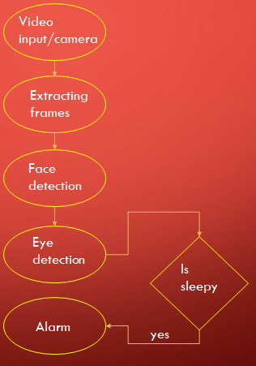

**Scope of project:**

* use in transporting truck, car, bus, traveller.
* This project will be put to use on tolls.
* Also, all car ,bus , truck making companies can install it in their vehicles.

**Limitations:**

* Lighting condition in background.
* Difficult to see significant deference between tired and alert drivers.

**Requirements:**

* Software requirements

implementation using

PYTHON

OPENCV

* IDEs

PYCHARM

* Hardware requirements

CAMERA

RASBERRY pi

BUZZER

**Proposed plan:**

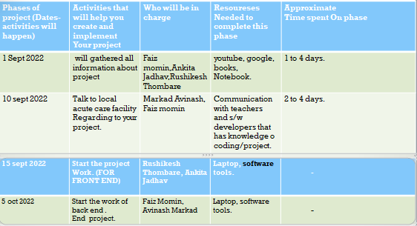

**References:**

<https://data-flair.training/blogs/python-project-driver-drowsiness-detection-system/>

<https://www.youtube.com/watch?v=qwUIFKi48&t=932s>

**Capstrone Project Planning**

**Title-Fake product Detection**

**Domain : blockchain.**

**Problem definition:**

* The promoting and profitability of the bothered companies are the stricken by the developing alternate in faux items. For the primary time, a studies proposed a completely operational blockchain.

**Description :**

The main motive of this project is to prevent from the loss of life or any other damages to the company or the organisation. Few years back the system were installed are now obsolete because they detect fire or smoke when it reaches the maximum level and until that time the loss was already done.

* The fire detection system is used to detect fire in air through camera in real time monitoring system based on Raspberry Pi.
* The main feature of this project is to alert generate when fire is started or reached it minimum level to prevent from loss of lives and damages or any other property.

**Proposed architecture:**

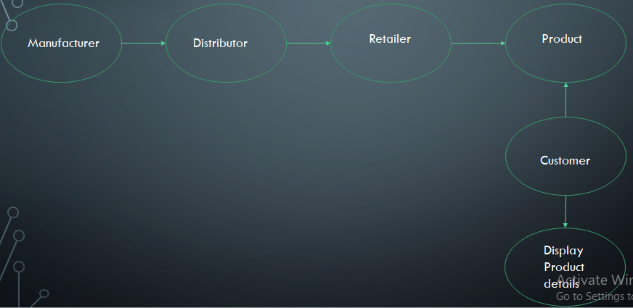

**Scope of project :**

* This project is use for the identify purchesed product is fake or not.
* The company will know if there is any changes in the product.
* The customer will also be able to determine whether the product is fake or not.

**Limitations :**

* If the QR code of the product and its id are pasted on another product, it cannot be identified**.**

**Requirements :**

Hardware :

Camera(Scanner)

Software :

* Programming languages

solidity

MYSQLDB

HTML,CSS

PYTHON

* Tool

VSCode

**Propose plan:**



**References:**

* <https://www.youtube.com/watch?v=6QkxHH-R-6Y>

**Capstrone Project Planning**

**Title-Fire Detection Using Raspberry pi3**

**Domain : internet of things(iot)**

**Problem definition :**

* fire is an very undesirable event that could bring a great loss of social wealth and health life. To prevent this losses, various alarm system have been developed such as smoke detectors. This systems detect the fire at basis of smoke.
* This project will help to detect the fire with the help of Image Processing. So we did not need any sensors. Here the camera will capture the video and separate the images into frames. And frames will compared to the original image. Which is already booted in Raspberry Pi.

**Description :**

* The main motive of this project is to prevent from the loss of life or any other damages to the company or the organisation. Few years back the system were installed are now obsolete because they detect fire or smoke when it reaches the maximum level and until that time the loss was already done.
* The fire detection system is used to detect fire in air through camera in real time monitoring system based on Raspberry Pi.
* The main feature of this project is to alert generate when fire is started or reached it minimum level to prevent from loss of lives and damages or any other property.
* **Proposed architecture**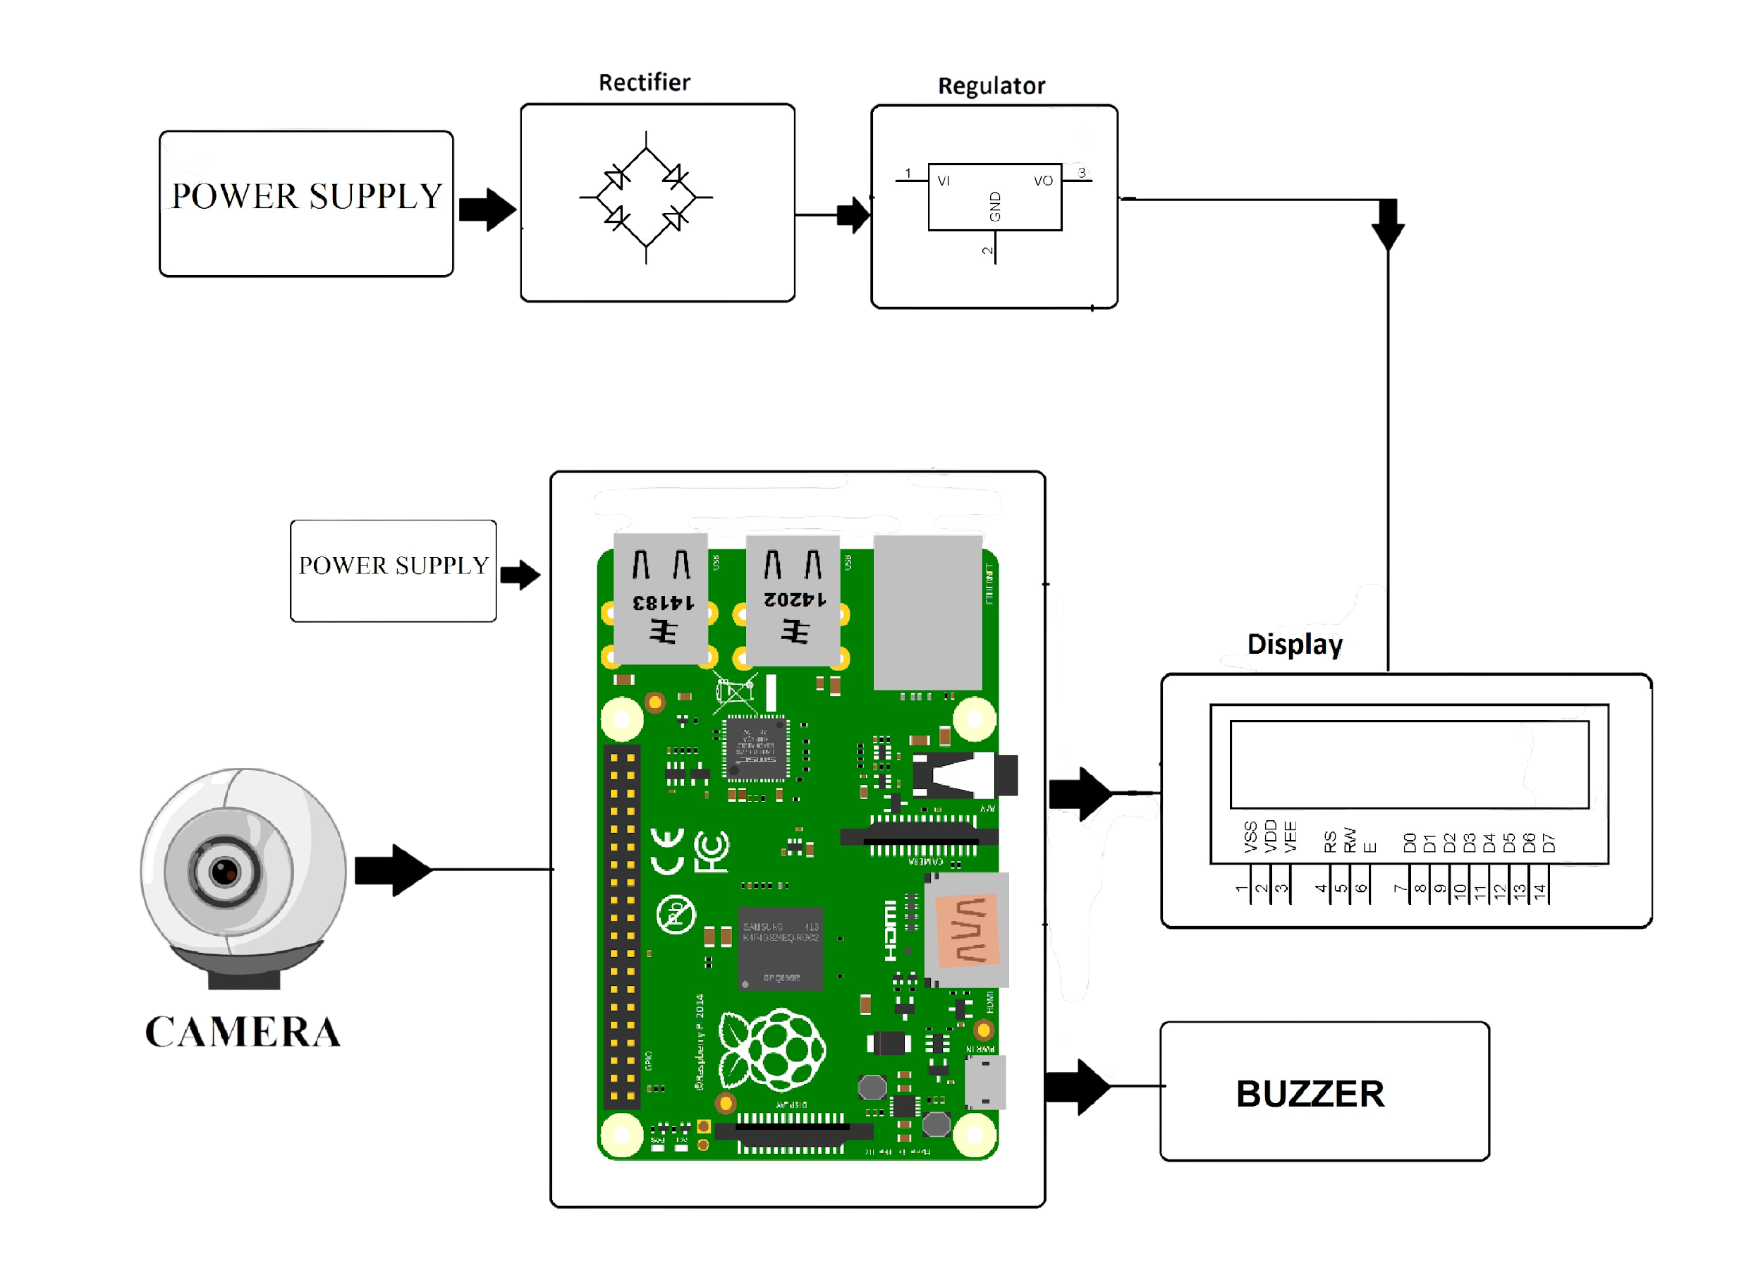

**Scope of project :**

This project can be used in different Areas :

1) Commercial buildings.

2) Malls.

3) Different Factories.

4) public places.

**Limitations:**

* This project will in some trouble at low lighting.
* This project will always require power source.
* Component can be little bit costly.
* So this process are costly and time taking.
* **Requirements:**
* Hardware :
* Raspberry Pi3
* Camera
* Buzzer
* LCD display
* pcb breadboard

Software :

* Operating System :
  1. Linux
* Programming Language
  1. Python

**Proposed plan:**



**References:**

For some information about this project

1)Google : [Fire Detection on a Surveillance System using Image Processing – IJERT](https://www.ijert.org/fire-detection-on-a-surveillance-system-using-image-processing)

How the project will perform

2)YouTube : <https://youtu.be/u6E3MtdmfRY>

Some books

3)Internet of Things: Principles and Paradigms

**Capstrone Project Planning**

**Title-Number Plate Recognition**

**Domain :- IOT (Internet of things)**

**Problem Definition:**

* At school/collage/office/parking places, the vehicles approaching the gate use notebooks to write down their numbers.
* In the notebook we can only write down the car number and the time at which the car comes. The number to be written in the book can be wrong or it can be changed. The number written in this notebook may be lost or damaged.
* In this project we can note everything that happens in the notebook, apart from that we can also record the photo of the number plate, the photo of the driver in our database.

**Description:**

* In this project, in the beginning, a photo of the number plate will be taken using a camera and it save in our storage.
* Aftertaking the photo of the number plate, the photo of the driver will be taken and it will be taken and it will also be saved in a folder in the storage.
* The camera is connected to the Arduino, the Arduino is programmed to automatically open the camera and take a photo of the number plate.
* This programming will be done using artificial intelligence. It will have the ability to recognize the number plate and take a photo of it.
* This project can actually be implement at the date of college/school or in the parking lot.

**Proposal Architecture:**

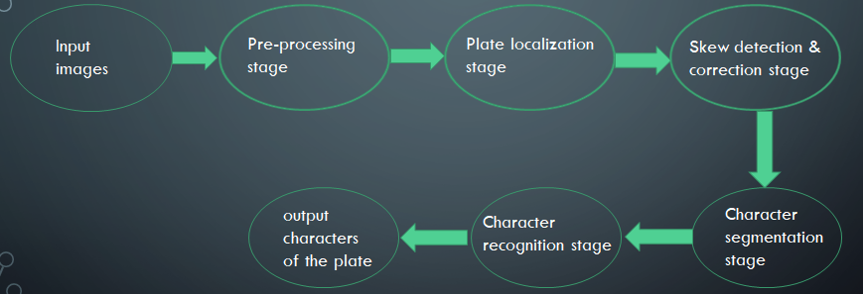

**Scope of project:**

* use for Parking Managements Monitoring
* any School/Collage Gate Monitoring
* any Office or Company Security Gate Monitoring
* This project can be used for record keeping in places such as toll, highway monitoring.

**Limitations:**

* This is not recognize at the situation of, small car, bike or object is continuously coming backside the big car or truck or any big object.
* That they rarely take into account human error and behaviour.

**Requirements:**

* Software requirements:-

1] Operating system

xinu operating system

2] Tool

programming language PYTHON

* Hardware Requirements

1] Peripheral Devices

Raspberry pi

Camera

2] Power supply

**proposed plane:**



**References:**

* <https://en.wikipedia.org/wiki/Automatic_number-plate_recognition>
* <https://www.youtube.com/watch?v=WLC4Fa4Ke3E>

**Capstrone Project Planning**

**Title-“RFID Based Electronic Passport Verification”**

**1)Domain:Internet Of Thing(IOT)**

**2)Problem Defination:**

The problems with paper passports are that they do not provide privacy, identity can be revealed to anyone who can physically access the passport. The paper passport can be used by someone else what is known as identity theft, data can be modified on the passport as everything is accessible and readable and it can be duplicated.

**3)Description:**

The main functionality of this project is to access the passport details of a passport holder through RFID and IoT technology. For this purpose, the authorized person is given an RFID card. This card contains an integrated circuit that is used for storing, processing information through modulating and demodulating of the radio frequency signal that is being transmitted. Thus, the data stored in this card is referred as the passport details of the person

**4)Proposed Architecture:**

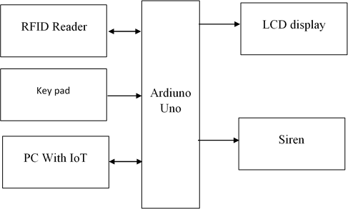

**5)Scope Of Project:**

Some common uses for RFID applications include :

1. Passport identification.
2. inventory management.
3. asset tracking and equipment tracking.
4. inventory control.
5. cargo and supply chain logistics.
6. vehicle tracking.
7. customer service and loss control.
8. improved visibility and distribution in the supply chain.

**6)Limitation:**

Reading multiple RFID Cards simultaneously may cause a collision, which leads to unwanted data loss .

**7)Requirement of Project:**

**Hardware Requirement:**

Ardiuno Uno

Node MCU

RFID Reader

LCD display

DC Motor

**Software Requirement:**

Ardiuno software

**8)Proposed Plan:**



**9)Reference:**

1)http://startingelectronics.org/beginners/start-electronics-now/tut3-starting-with-auduino/.

2)www.circuits.com/interfacing-lcd-to-auduino.

3)www.electronicdefinations.com/defination.php?defid=2474

**Capstrone Project Planning**

**Title-Smart Agriculture**

**Domain:- Internet of things(iot)**

**Problem definition:**

* An automated irrigation system is needed to optimize water use for agricultural crops, plants in biodiversity park.
* The technique can be used for application of accurate amount of water.
* By sensor, good monitoring of water regulation in the agriculture field can be achieved.

**Description:**

* It will be checked that place or that plant needs water or not by using the soil moisturizer sensor. Also he check temperature in air by using the humidity sensor.
* This project has the ability to automatically turn on and off the supply of water. This project will be used to biodiversity parks, farms, forests, trees in college campus.

**Proposal Architecture:**

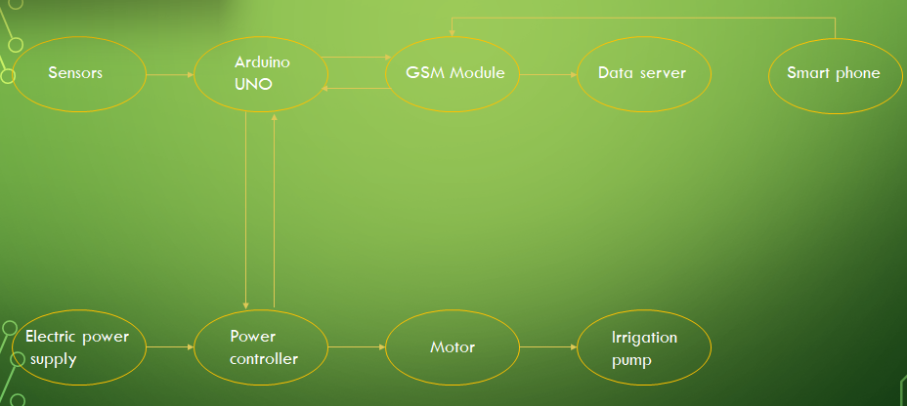

**Scope of project:**

* This system will helps the farmer to overcome the drawbacks of traditional irrigation system.
* Due to automatically handling, user requires less man power.
* Water will be saved by using this technology.
* This technology provide sufficient water to the plant.
* With the help of the sensors, it can accurately determine the soil moisture levels.

**Limitations:**

* High initial investment requirement.
* Automated irrigation system uses only two parameters of soil like soil moisture and temperature other parameters humidity, light, air moisture, soil ph value not taken for decision making.
* Installing is difficult.

Difficult to maintaining equipment

**Requirements:**

* Software requirements

Languages

HTTP+HTML

MYSQLDB

Tool

VSCode

* Hardware Requirements

Arduino

Relay

Humidity sensor

AC pump

Moisture sensor

**proposed plane:**



**References:**

* [https://ondo.io/what_is_smart_agriculture/](https://www.youtube.com/watch?v=J2q4s4HUPYI)
* [https://nevonprojects.com/iot-based-smart-agriculture-monitoring-system-project/](https://www.youtube.com/watch?v=J2q4s4HUPYI)
* <https://www.youtube.com/watch?v=J2q4s4HUPYI>

**Capstrone Project Planning**

**Title-Smart Trolly**

**Domain:** **Internet of things(IOT)**

**Problem definition:**

* The current system involves a large amount of manual handling on the part of the customer.
* It helps in tracking and identification of trolleys, which is useful for the management of the shop but does nothing for the customer.
* It does not provide a feasible solution to reduce the time spent by the customer in the store, mainly while standing in line for billing and payment.

**Description:**

* In this regard, the Internet of Things (IoT) based Smart Shopping Cart is proposed which consists of Radio Frequency Identification (RFID) sensors, Arduino microcontroller, Bluetooth module, and Mobile application.
* FID sensors depend on wireless communication.
* It has Barcode scanner and touchscreen display, which can be used to scan the products and display the product information, cost and total bill.

**Proposed architecture:**

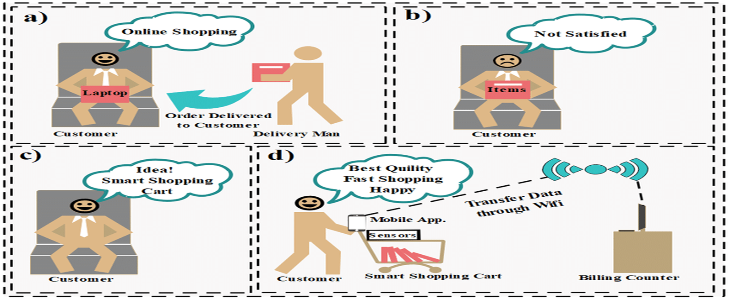

**Scope of the project:**

* This project will be use in super malls.
* Also this use in shopping centers**.**

**Limitations:**

* It will be expensive, because per product card is important.
* The FID card is important, if it gets damaged, the product will be not billed.

**Requirements:**

1] Hardware requirements

Raspberry pi

125kHz

bill switch

RFID tags or card

LCD display

RFID card reader

2] Software requirements

linux operating system

**Proposed plan:**



**References:**

* <https://www.youtube.com/watch?v=D831-Y7w1T8&t=19s>
* <https://www.researchgate.net/figure/FIGURE2-Architecture-design-of-smart-shopping-cart-based-on-RFID-technology_fig2_340520982>

**Capstrone Project Planning**

**Title-Voice Based Email For Visually Challenged**

**Domain:-Internet Of Thing(IOT)**

**Introduction:-**

We have seen that the introduction of Internet has revolutionized many fields. Internet has made life of people so

easy that people today have access to any information they want easily. Communication is one of the main fields

highly changed by Internet. E-mails are the most dependable way of communication over Internet, for sending and

receiving some important information. But there is a certain norm for humans to access the Internet and the norm is

you must be able to see. But there are also differently abled people in our society who are not gifted with what you

have. There are some visually impaired people or blind people who can't see things and thus can't see the computer

screen or keyboard. A survey has shown that there are more than 240 million visually impaired people around the

globe. That is, around 240 million people are unaware of how to use Internet or E-mail. This system aims at

developing an email system that will help even a visually impaired person to use the services for communication

without previous training. The system is completely built on interactive voice response which will make it userfriendly and efficient to use. The entire project is based on voice interaction which means speech recognition and synthesis.

**Problem Definition:**

The project title voice based email system is a web based application developed that allows blind people to ues email system easily.The peoposed system focuses on providing the basic functionalities like composing,reading,sending and receving emails along with voice based interaction.

**Scope of the Project:**

it can improve the accuracy of message content and it allows to send multiple message to multiple people. Voice mail can allow the message to be easily updated and it can reduce the need of receptionist it can serve as an important medium for business in communication.

There is wide future scope of this system many enhancements can be done in the system such as including different languages, including functionality of accessing the deleted mails and spam mails. Also, this system can be enhanced such that it can also send attachments which are more beneficial for visually challenged people. This system can be made available to all regional people who are not educated enough and inclusion of different languages will make this system easily accessible. Furthermore sign language system can also be integrated with the system to make the system more scalable and robust.

**Limitation of the Project.**

* Some people cannot use the voice-messaging systems.
* difficult for people to recall which options they used previously.
* You will get tired of listening to the messages and end up deleting the messages without
* listening to them, This causes you to miss the important messages.

**Requirements:**

* **Software: ▪ IDE**
* **text-to-speech API**
* **speech-to-text API**
* **Hardware requirements**
* **8gb ram**
* **I5 processor**
* **512gb SSD**

**Proposed Plan.**



**Reference.**

* java Mail API Elliott Rusty Harold O'reilly, Incorporated 2013 https://[www.geeksforgeeks.org/voice-based-android-mail-system-forvisually-impaired](http://www.geeksforgeeks.org/voice-based-android-mail-system-forvisually-impaired)
* https://[www.opensourceagendJa.com/projects/voice-based-email-for-blind](http://www.opensourceagenda.com/projects/voice-based-email-for-blind)

**Capstrone Project Planning**

**Title-Attendence System**

**Domain:- Artificial Intelligience**

**Problem Definition:-**

* Face Recognition is a biometric method od identifying an individual by comparing live capture or digital image data with the stored record for that person.
* Face Recognition Attendance System is marking of attendance based on this technology.

**Description:**

* Attendance is a compulsory requirement of every organization. Maintaining attendance register daily is a difficult and time consuming task.
* As it is known that primary identification for any human is its face, face recognition provides an accurate system which overcomes the ambiguities like fake attendance, high cost, and time consumption.
* This system uses face recognizer library for facial recognition and storing attendance.

**Proposed Architecture:**

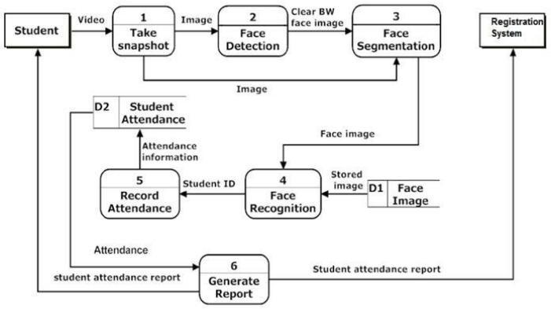

**Scope Of Project:**

* This project main use is Attendance is automatically stored in database.
* Provides an automated attendance system that is practical reliable and eliminate disturbance and time loss of traditional attendance system.
* Industry, Colleges, Offices this project is useful for automatically attendance .

**Limitations:**

* This project will in some trouble at low lighting.
* This project will always require power source.
* Students or workers wear helmets or anything the sensor not captures.

**Requirements:**

* Operating System
  1. Windows
* Programming Language
  1. Python
* Hardware
* 1.camera

**Propose Plan:**



**References:**

* [**https://www.youtube.com/watch?v=sz25xxF_AVE**](https://www.youtube.com/watch?v=sz25xxF_AVE)
* **Book name: Artificial Intelligence: A Modern Approac**
* **Authors name: Stuart J. Russell & Peter Norvig**

**Capstrone Project Planning**

**Title-Heart Monitoring System**

**Domain-**

**Problem Definition:**

* Monitoring heart rate is very important for athletes, patients as it determines the condition of the heart (just heart rate).
* Heart Monitoring System is helpful for a cardiac event monitor is a device that you control to record the electrical activity of your heart(ECG).This device is about the size of a pager.It records your heart rate and rhythm.cardiac event monitors are used when you need long-term monitoring of symptoms that occur less than daily.The aim of this project

**Description:**

* Heartbeat sensor is an electronic device that is used to measure the heart rate that is speed of the heartbeat .Monitoring body temperature,heart rate and blood pressure are the basic things that we do in order to measure the body temperature, we use thermometers and a sphygmomanometer to monitor the arterial pressure or blood pressure. Heart rate can be monitored in two ways:

one way is to manually check the pulse either at wrists or neck and the other way is to use a Heartbeat Sensor. Pulse oximetry is used in this project to detect the heartbeat using fingers. When the heart expands (diastole) the volume of blood inside the fingertip increases and when the heart contracts (systole) the volume of blood inside the fingertip decreases.

**Proposed Architecture:**

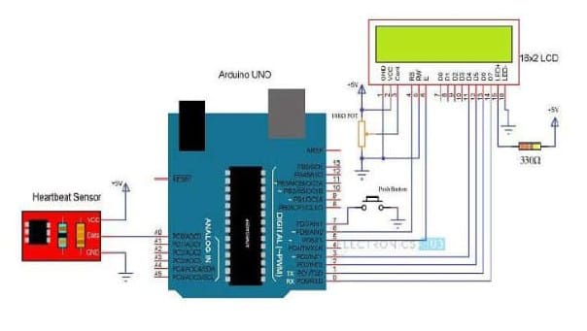

**Scope Of Project:**

* The scope were defined into the customers who are mostly patient or are in need to
* keep track of their daily heartbeat rate. The limitations were referred to its software
* programming where it only senses the heartbeat rate. The sensing elements made of eco-friendly substances and materials.

**Limitations:**

* More likely to be worn incorrectly, either not tight enough or too tight. 1] Not necessarily accurate in sports where you move your hands vigorously or flex the muscles and tendons near your wrist.
* Limited ability to accurately measure heart rate through dark or tattoed skin.

**Requirements:**

* Hardware Requirment:
* The fingertip sensor
* LCD Display
* ECG sensor
* 9v DC Battery
* Battery clips connecter
* Button switch
* Breadboard

**Propose Plan:**



**Reference:**

* https://www.researchgate.net/publication/10746534_Heart_rate_monitoring_applications_and_limitations